Ketso Notes
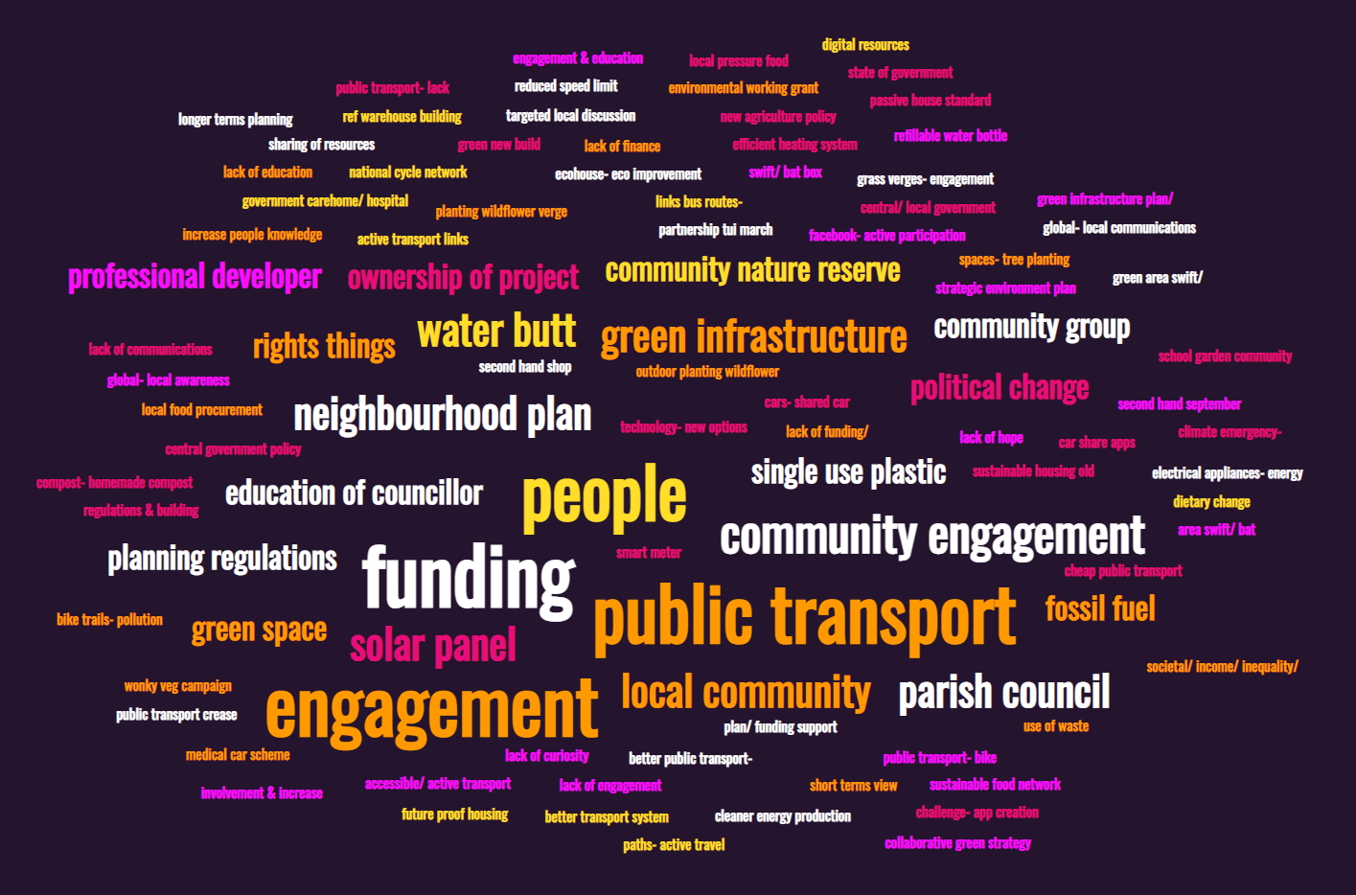
Image: Most common words from the Ketso exercise

High Barn
Waste
- Reduction in plastic production and production
- Recycling incentives promoted. Non-recyclable goods. Reduction in single use plastics on products i.e. groceries
- Curbside recycling
- Stop charging at recycling centres
- Stop charging for recycling bins
- Interacting with communities re what is being done locally, initiatives and how people can get involved well-articulated and circulated strategy
- Political activism to change people’s lives
- Recycling
- Recycling plastics, food waste, green waste
Nature
- Monitoring water levels and not wasting water. Water controls
- Increasing biodiversity
- Awareness of our shared responsibility for the environment
- Education of councillors on environmental issues
- Government legislation
- Set achievable targets across public and private sectors nationally/ locally
- Wilding/ rewilding
Water
- Valuing water (resource) responsible usage
- Pressure the government to do the right thing
- Nonpolitical collaborative green strategy and vision
- Ownership of project all ages to be involved if possible
- Information readily available
- Education at a school level needs to be included in the curriculum, more hands on practical activities, school gardens community workshops
- Political change. Funding made available for incentives/ tech/ education
- Finance availability
- Climate Café
- Info in local magazine
- Environmental working grants

Housing
- Reduce GHG housing. Renewable resources. Insulation
- Sustainable Housing Old. New. Passive house standard
- Sustainable planning. Joint strategy. Housing. Transport
- New Builds. Eco friendly
- Councils to encourage planners to be more ecofriendly when granting approval
- Political change
- Community engagement- Facebook- active participation
- Central government policy for planning strategy. Future proof housing
- Engagement with builders and developers
- Education of green issues passing on experience
- Ownership of project all ages to be involved if possible

Transport
- Accessible/ active transport
- More rural Transport
- Engage with and encourage community
- Reduce GHG transport. more public transport free. green transport
- Better transport systems including walking, bike paths- active travel
- Leadership and community involvement
- Electric Transportation
- Idling signs- encourage people to not con engines
- Greening bus shelters
- Alllotments
- Bee squared project
- Green highways; involve people. Community nature reserve
- Outdoor planting wildflower verge (parish council)

Energy
- Longer term planning for sustainable initiatives for energy
- Information communicated
- Technology- new options for removing non-recyclables. Energy solutions
- Generating own power (solar)
- Awareness and education on what the issues are and our consumption

Food
- Bug local pressure food
- Local food procurement across the local government care home/ hospital
- Community fridges. Reduce waste
- Funding for community engagement. Food miles. Waste
- Spreading funding locally from central/ local government. Community groups and charities
- NN sustainable food network
- Reusable and refill bottles, locally sourced food
Barriers
- Political commitment that resists easy answers
- Apathy. Greed. Political will. No voice for “the people”
- Negative mindset
- Confusion
- The small state of government
- Me!
- Overcoming human nature. Need a sharing attitude
- Lack of funding/ political will
- Government changing legislation to make us do the right thing
- Lack of finance to support
- Timescale too slow to implement legislation (GOV)
- Poverty
- Societal/ income/ inequality/ planned obsolescence
- Consumerism
- Getting people involved and interested. Finance. Legislation
- Education (or lack of)

Low Barn
Waste
- Destigmatising charity shops and food banks
- Recycling
- packaging
- buying from second hand shops
- make single use plastic illegal
- Second hand September
- Refillable water bottles and bags
- Cloth nappies
- Reusing natural materials
Nature
- Planting
- Biodiversity action plans
- Saving existing green spaces
- Conservation
- Bees
- Green infrastructure
- Productive use of green spaces
- No- Mow
- River restoration
- Alteratives to pesticide use
- Community nature reserve
- Encouraging and feeding birds- no mow may
Water
- Focus on the positives
- Bigger role for governments
- Talks in schools
- Targeted local discussions
- Funding (local/ national)
- Community survey
- Community groups
- Vote
- Climate education
- Engagement
- New water butts
- Conserving water- using less + greywater

Housing
- Insulating buildings
- Net zero housing
- Insulation
- Planning regulations & Building regulations
- Planning regulations
- Housing
- Pressure on big businesses
- Education and community engagement
- House builders have to engage with local communities
- Lobby your elected representative
- Lobbying
- Attend council meetings and ask questions
- Strategic environment plan for villages
- Green new builds
Transport
- Improve public transport
- Shared transport
- Public transport
- Active travel
- Transport
- Practice what you preach
- Education for all ages
- School bus – electric – park and ride
- Walking bus
- Electric cars
- Using public transport
- Train not plane
- Flight free pledge
- Car sharing
- Greenway- sustainable networks
- Cycling and walking

Energy
- Fossil fuels stop
- Renewable energy
- Divest from fossil fuels
- Influencing communities
- Do it now!
- Information communicated
- Online training
- Smart meters
- Switch off!
- Digital resources
- Turning things down, thermostat, washing machine, shower
Food
- Reduce meat consumption
- Food wastage
- Sustainable farming
- Do it now!
- Wonky veg campaign
- Dietary changes
- Plant based diet
- Composting
- Community larder

Barriers
- Government Policy
- Political will
- Bureaucracy
- Politics
- Government
- Communication
- Engagement
- £
- Money
- Apathy
- Funding
- Lack of communication
- Weather
- Lack of hope
- Lack of education
- Time
- Self interest
- Landowner
- Resources
- PFI!
- Short termism
- Knowledge
- Competition
- Reluctance to change
- Making it appealing

Farm House
Waste – Not completed for this cohort
Nature
- More engagement with farmers
- Focus on pollinators
- Challenge the new agriculture policies where they work against organisms
- Climate emergency- how to respond- huge step-gist need will- embrace smaller projects
- Getting involvement & increase peoples knowledge
- Rewilding grass verges- engagement & education of councillors and members of the public
- I will talk to neighbours and those that represent to see if they support the movement
- Networking, listening, communicate, community engagement, make things fun
- I will ask my parish council about what street trees are planned
- Find local champions to support plans
- Involve schools in any initiative
- Central support for communities and parish councils to deliver community projects relating to green infrastructure, climate emergency, funding; advice; support.
- Landscape scale collaboration
- Peat free compost- homemade compost
- Restoring green areas swift/ bat boxes, engage villages
- Rewilding churchyards, engagement with schools, ‘adopt a grave’
- Community spaces- tree planting, bee hives, tree trails
Water
- Flood defenses, wetlands, not developing on flood planes, reduce water useage, water butts
- Pollution of local waterways
- More regulation
- Central coordinating support
- Water butts
- Rinse only hair washing
Housing
- Home insulation
- Swift bricks in new buildings
- Change building regulations- eco friendly options-green energy
- Enforcing planning conditions
- Difference between policies and grassroot action- global- local communication and cascading
- Political will and funding from parish to unitary- awareness of the climate crisis
- Imbalance professional developers and influence from local communities
- Developing neighbourhood plans
- More regulation
- Neighbourhood plan- inforcing planning policy
- Ecohouse- eco improvements
Transport
- Make public transport more accessible, usable, affordable
- Public transport getting people out of cars- shared cars
- School transport
- Safe cycling- reliable public transport crease
- Better public transport- bike trails- pollution monitoring- link bus routes- car share apps
- Cheap public transport with safe & easy active transport links to link home with bus
- Hybrid cars
- 100% national cycle network off road and quiet way (reduced speed limit) by 2040
- Green/ efficient transport, walk, multitask trips
- Keep bus service going- work in partnership Tui March 23 future?
- Medical car scheme

Energy
- Green roofs or solar panels
- Reduce waste
- Cleaner energy production offshore, nuclear
- Policy change ref warehouse building, solar panels, token gesture
- Efficient heating systems
- Electrical appliances- energy saving better
- Solar panels, heat pumps, wind turbines- raising awareness of polluting wood burners
Food
- Smell it, taste it, don’t waste it
- Food challenge- app creation collaborated sharing of resources
- Publicise- Smell it, taste it, don’t waste it
- Community fridge- use of waste food- grow your own- eating seasonally
- Buy local food where you can
- Allotments

Barriers
- Lack of engagement
- Support from ACRE or unitary to write a green infrastructure plan/ funding support, communicate
- Developing neighbourhood plans
- ‘not my problem’ water
- Apathy
- Councillor apathy- lack of funding
- Lack of curiosity
- Selfishness
- People need to have the knowledge of the need for change- global- local awareness for change
- Businesses interested in profit
- No community spirit
- Personal time/ outside of the week +life demands to contribute to making a change
- NIMBYISM
- Sacrifices required
- Short term view
- Economic inequalities
- Public transport- lack of and cost
- Upfront costs too great
- Imbalance professional developers and influence from local communities
- Developing neighbourhood plans

